VISVESVARAYA TECHNOLOGICAL UNIVERSITY, JNANASANGAMA, BELAGAVI - 590018


R.T.E. Society’s
Rural Engineering College, Hulkoti- 582 205
Department of Computer Science

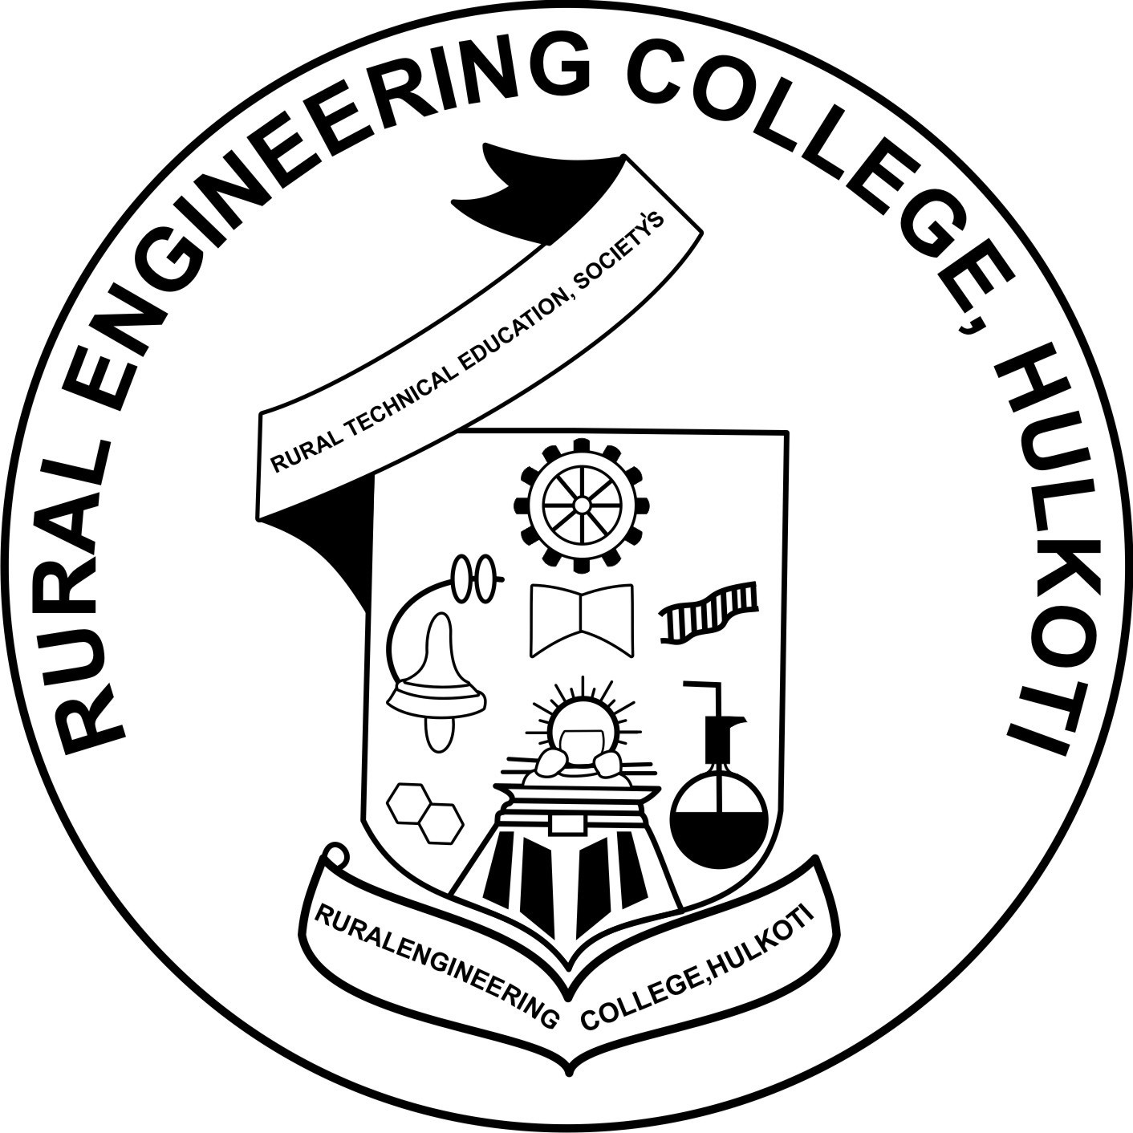

ACTIVITY REPORT
ON
MIYAWAKI FOREST

Academic Year: 2025-26 Semester: 1st

Student Name: VRUSHABH C BABANNAVAR Roll No: 79

Branch: Computer Science

Team Name: THE ROYAL SQUAD

Mentor: Mr. Suresh Sadmal

Miyawaki Forest

1. Introduction:
The Miyawaki Forest is a method of afforestation developed by Japanese botanist Dr Akira Miyawaki. This technique focuses on growing dense, native forests in a short span of time. Unlike traditional plantations, Miyawaki forests grow 10 times faster, become 30 times denser, and are 100 times more biodiverse. This method is highly effective in restoring degraded land and improving environmental sustainability, especially in urban and semi-urban areas.

2. Aim:
To study and understand the Miyawaki Forest technique, its working process, advantages, and its role in environmental conservation.

3. Objectives:
- To understand the concept of Miyawaki afforestation
- To learn the steps involved in creating a Miyawaki forest
- To analyse its environmental benefits
- To study its importance in urban ecosystem restoration

4. Concept of Miyawaki Forest:
The Miyawaki method involves planting native tree species very close to each other after improving soil quality. Due to dense planting, trees compete for sunlight and grow rapidly. The forest becomes self-sustaining within 2–3 years and does not require regular maintenance after that.

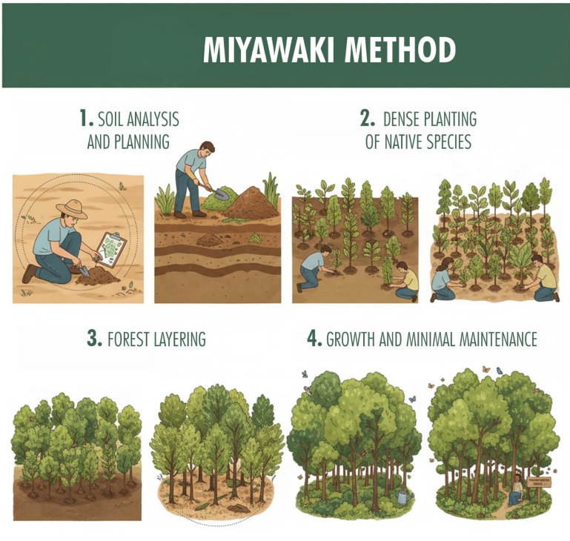
5. Methodology / Working Process:
- Soil Analysis – Testing soil type and nutrients
- Soil Preparation – Mixing biomass like coco peat, rice husk, compost
- Selection of Native Species – Trees, shrubs, and ground cover plants
- Dense Plantation – 3 to 5 saplings per square meter
- Mulching – To retain moisture and protect the soil
- Maintenance – Watering and care for the first 2–3 years

6. Advantages of Miyawaki Forest:
- Grows 10x faster than conventional forests
- Improves air quality by absorbing CO₂
- Increases biodiversity (birds, insects, animals)
- Prevents soil erosion
- Reduces urban heat island effect
- Requires less maintenance after the initial years
- Enhances groundwater recharge

7. Applications:
- Urban areas and smart cities
- Schools, colleges, and institutions
- Road sides and industrial zones
- Parks and residential layouts
- Waste lands and degraded lands

8. Necessity of Miyawaki forest:
- Rapid forest growth - needed due to deforestation
- More oxygen & clean air - needed due to pollution
- Small land use - needed in crowded cities
- Heat reduction - needed because of global warming
- Biodiversity support - needed to protect nature
- Soil & water improvement - needed for environmental balance
- Climate control - needed to fight climate change
9. Role in Sustainable Development:
Miyawaki forests support sustainable development goals (SDGs) by promoting environmental protection, climate action, and ecosystem restoration. They help in balancing urbanisation with nature conservation.

10. Result / Outcome:
The Miyawaki method successfully creates a dense, natural forest in a short time. It improves environmental quality, supports wildlife, and provides a green solution for land restoration.

11. Conclusion:
The Miyawaki Forest technique is an effective, eco-friendly, and sustainable approach to afforestation. It is especially useful for urban environments where space is limited. Adopting this method can significantly contribute to a greener and healthier future.

*****

